LAB 9

- Write a GPSS program to simulate a barber shop for a day (10 am to 5 pm) where a customer enters the shop every 10+-3 minutes and a barber takes 4+-2 for a haircut.

Code:
*Q1
SIMULATE
GENERATE 10,3
QUEUE SEAT
SEIZE BARBER
DEPART SEAT
ADVANCE 4,2
RELEASE BARBER
TERMINATE 1
START 420

Output:
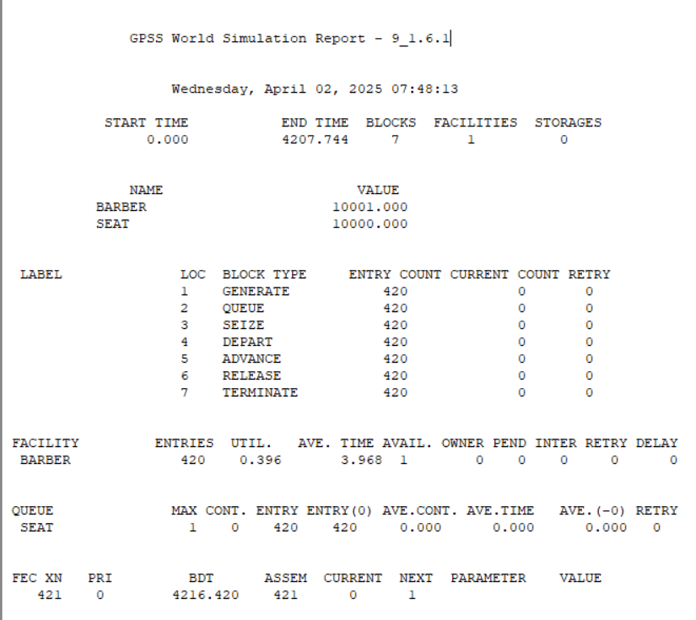

- A machine tool in a manufacturing shop is turning out parts at the rate of one every 5 minutes. As they are finished the parts go to a inspector who take 4+-3 minutes to examine each one and rejects 10% of the parts. Write GPSS program for 1000 parts.

Code:
GENERATE 5
ADVANCE 4,3
TRANSFER 0.1 ACC,REJ
ACC TERMINATE 1
REJ TERMINATE 1
START 1000

Output:
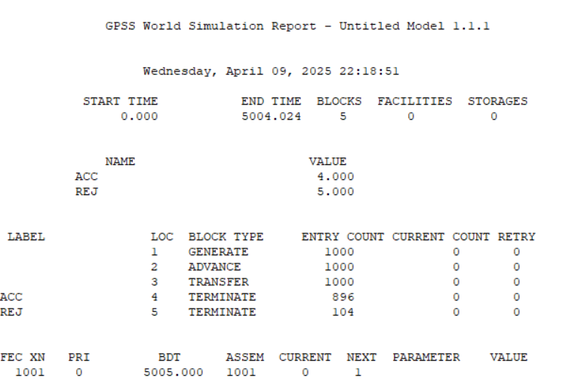

- Implement Qno 2 using facility

Code:

GENERATE 5
SEIZE INSPECTOR
ADVANCE 4,3
RELEASE INSPECTOR
TRANSFER 0.1 ACC, REJ
ACC TERMINATE 1
REJ TERMINATE 1
START 1000

OutpuT:
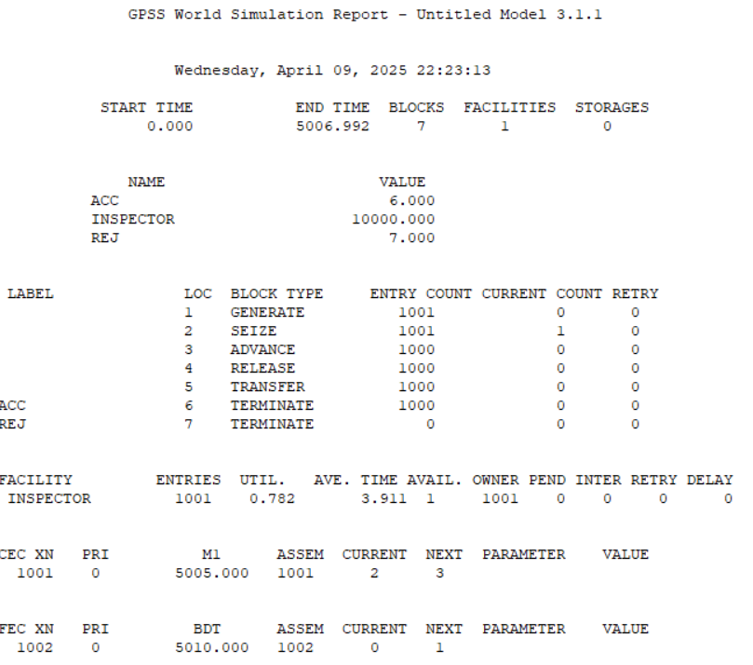

- A machine tool in a manufacturing shoP is turninG out parts at the rate of every 5 minutes. When they are finished, the parts are sent to an inspector, who takes 4+-3 minutes to examine each one and rejects 15% of the parts. Write a GPSS program to simulate using the concept of facility.

Code:
GENERATE 5
SEIZE INSPECTOR
ADVANCE 4,3
RELEASE INSPECTOR
TRANSFER 0.15 ACC, REJ
ACC TERMINATE 1
REJ TERMINATE 1

Output:

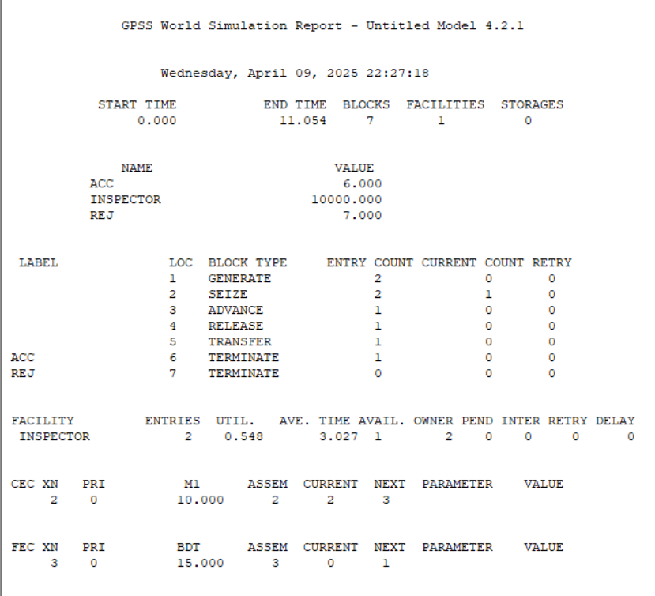

LAB 10

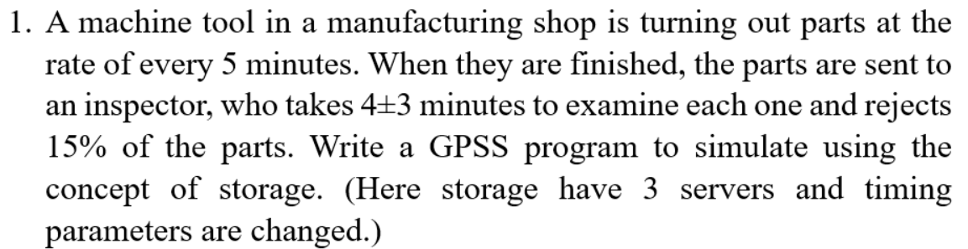

Code:
GENERATE 5,,,1000
ENTER INSPECTOR,1
ADVANCE 4,3
LEAVE INSPECTOR,1
TRANSFER .15, REJECT
TERMINATE 1
REJECT TERMINATE 1
INSPECTOR STORAGE 3

Output:
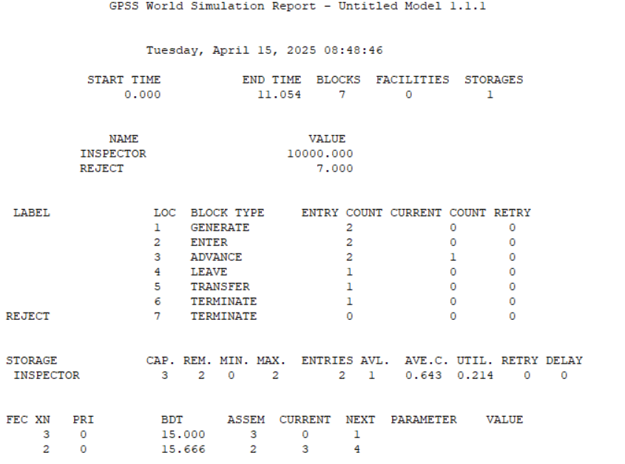

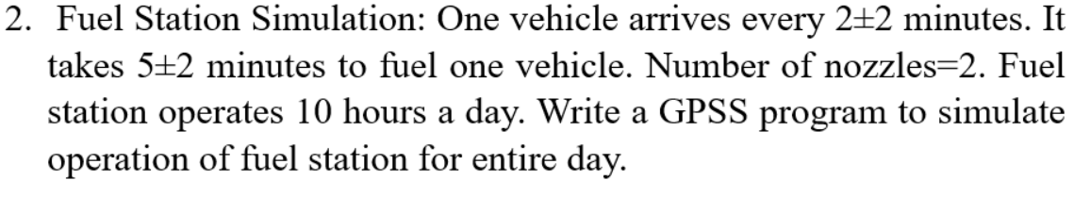
Code:
GENERATE 2,2
QUEUE FUELQ
ENTER NOZZLE,1
DEPART FUELQ
ADVANCE 5,2
LEAVE NOZZLE,1
TERMINATE 1
NOZZLE STORAGE 2
START 600
Output:
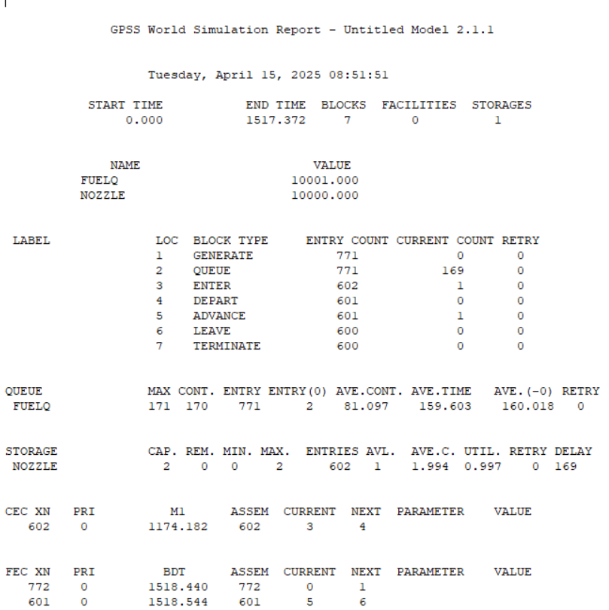

Lab 11
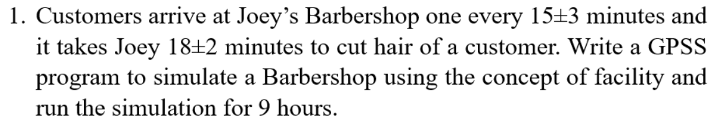
Code:
GENERATE 15,3
QUEUE BARBERQ
SEIZE JOEY
DEPART BARBERQ
ADVANCE 18,2
RELEASE JOEY
TERMINATE 1
JOEY STORAGE 1
START 540
Output:
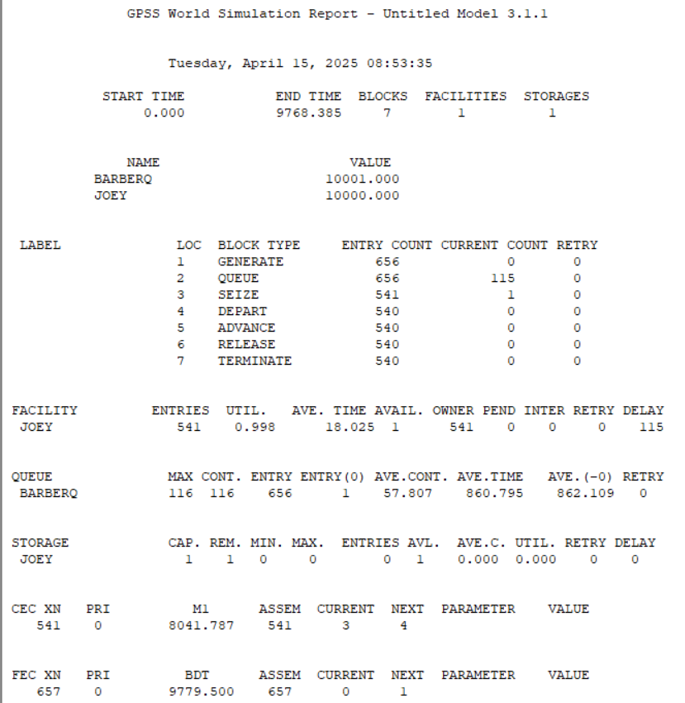
Q.2. Simulate random walk problem or a drunkard problem in any programming language.
Source code:
#include <stdio.h>
#include <stdlib.h>
#include <time.h>
int main() {
int position = 0;
int steps, i;
printf("Enter number of steps: ");
scanf("%d", &steps);
srand(time(0));
for (i = 0; i < steps; i++) {
if (rand() % 2 == 0)
position--;
else
position++;
}
printf("Final position: %d\n", position);
return 0;
}
Output:
